1. Nix

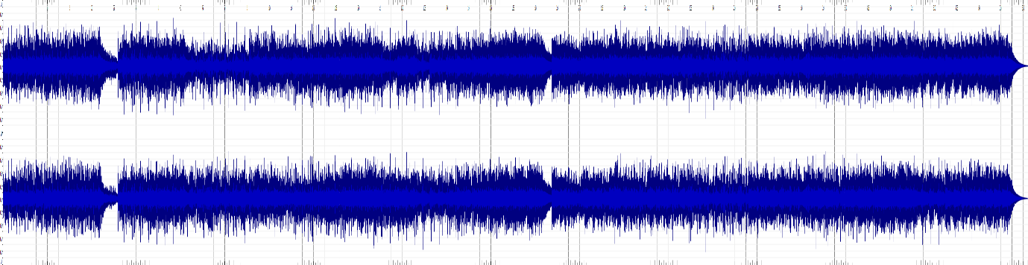

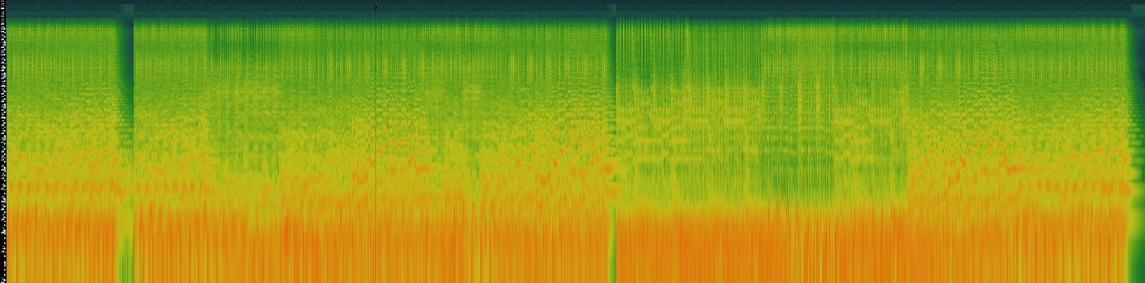

1. Upbeat Party

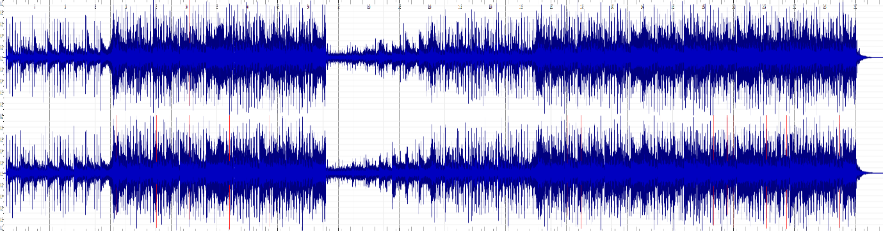

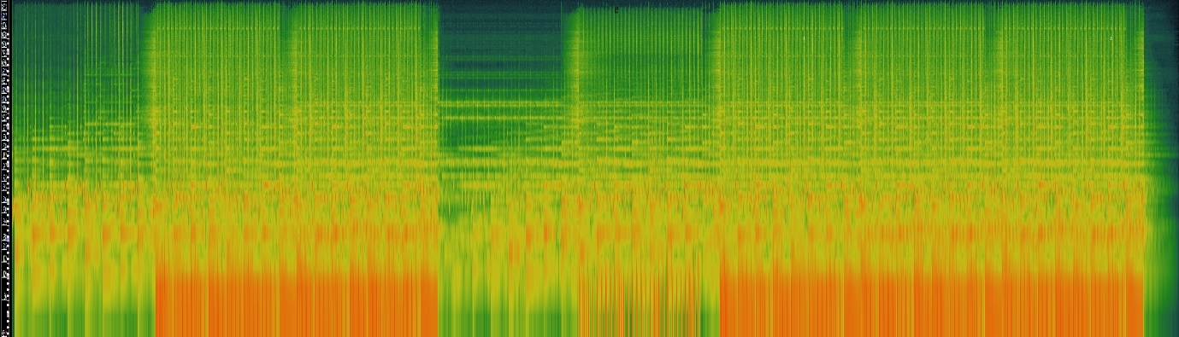

1. Farewell

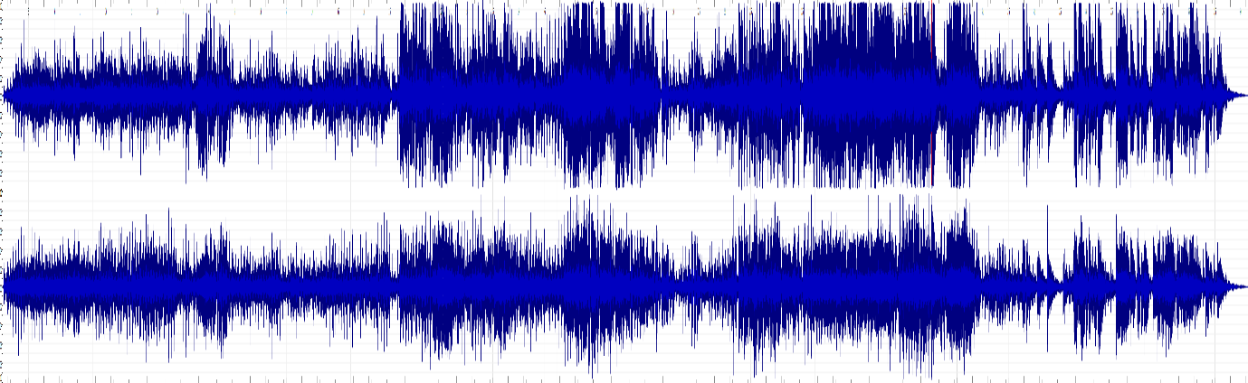

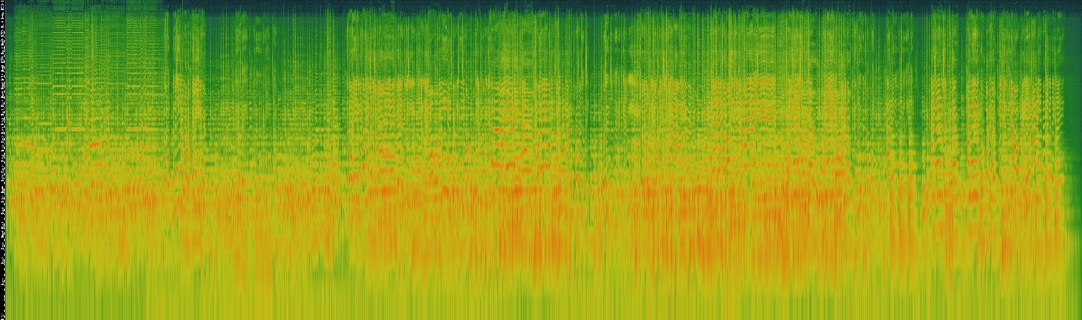

One advantage of a time-frequency analysis over a waveform-based analysis

: By differentiating colors it avoid confusing real components from artifacts or noise.